# Individual Concept generation: z5217814

Concept generation is a critical step in the design process after problem specification as it is able to produce a large array of possible design alternatives which are based off target product features and specifications that are clearly defined in the problem statement. This step is also key to undertake when attempting to develop initial designs as it allows us to creatively and abstractly imagine as well as conceptualize all possible ideas rather than eliminating possible designs due to prejudgement of certain designs.

In my individual concept generation, I utilised a morphological chart for a specific function for the project, the movement of the main body.

|  |  |  |  |
| --- | --- | --- | --- |
| **Function** | **Solution 1** | **Solution 2** | **Solution 3** |
| 1. Horizontal movement (speed) | Use of 1 DC motor with 2 wheels, speed controlled by power supplied | 2 DC motors with 2 wheels each, connected separately, constant speed | 2 DC motors with 2 wheels each, speed of both motors are controlled by Arduino board |
| 1. Direction of movement   (forwards /backwards movement, braking) | Direction of current supplied to motor | 2 DC motors whose direction of movement oppose (one forward, one backward) | Use of signals from Arduino board to determine direction when desired |
| 1. Stability of the body while in transit | Multiple wheels to provide additional traction and stability | Wheels with slight protrusion over guide rails | Avoid loose components that may contribute to swinging |

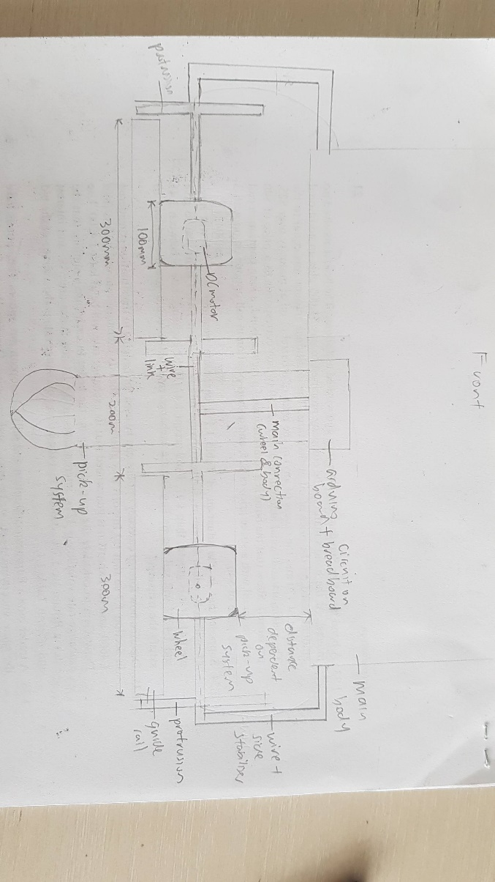The ideas generated within solutions 1 & 2 mostly do not include the functional element of the Arduino board. However, it was clear that the use of the board can simplify as well as allow much greater control and customization over the movement of the main body, especially as the detection of pickup & delivery locations must interact with the movement function to ensure precise movement. Thus, the solutions for function 1 and 2 were selected mainly due to the inclusion of the Arduino board, while function 3 was implemented through a combination of all suggested solutions.

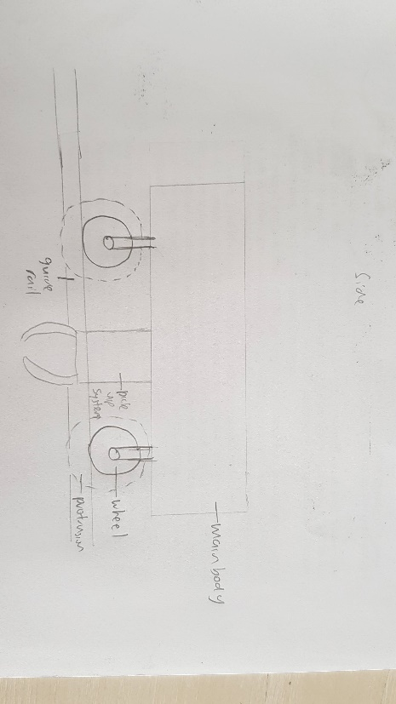 Next, a varied ‘C Sketch’ method was utilised to generate rough designs continuously and allow continuous improvement through iterative designs. The final design concept was decided through a combination of both methods, the chart was able to describe the functions and how to implement conceivable solutions for them while the sketches allowed for a much visual understanding of the problem and allowed for a deeper understanding of the design.

Above is the side view, shows how the pickup system will fit in between the pairs of wheels. More pairs can be implemented but for functionality purposes, two pairs is enough.

Above is the front view of the main movement system. As we can see, the illustration shows a pair of wheels with a DC motor within each, as well as a protrusion that wraps around the guide rail. The wheels are connected through a strong and rigid material (metal, plastic) to the main body & Arduino board, which also acts as a way for the wire/connection to run through.